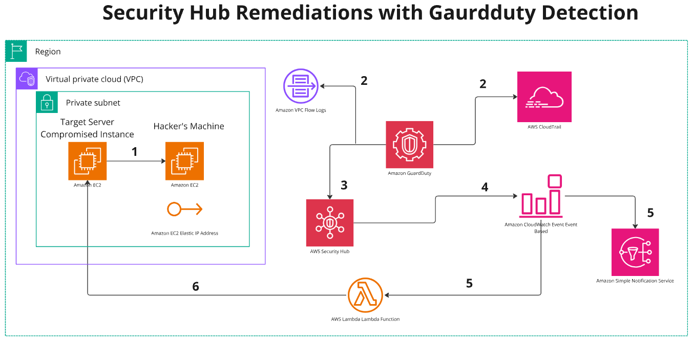
This AWS Security Hub Remediations with GuardDuty Detection diagram illustrates how AWS services work together to detect and remediate security threats in an AWS environment.
Step-by-step Explanation:
- Attack on the Target Server (Compromised Instance)
  - A hacker's machine (an EC2 instance) attempts to compromise a target server (another EC2 instance) inside a private subnet within a VPC.
  - This attack could involve SSH brute force, data exfiltration, malware, or other malicious activity.
- Logging and Threat Detection
  - AWS VPC Flow Logs and AWS CloudTrail capture network and API activity in the AWS environment.
  - VPC Flow Logs monitor network traffic between the target server and the hacker’s machine.
  - AWS CloudTrail records API calls made within the AWS account, which helps in detecting unauthorized access or suspicious actions.
- Threat Detection by AWS GuardDuty
  - Amazon GuardDuty analyzes the collected logs (VPC Flow Logs and CloudTrail data).
  - If suspicious activity is detected (e.g., unusual network traffic, connections to known malicious IPs, or unauthorized API actions), GuardDuty generates a security finding.
- Security Hub Aggregates Findings
  - The AWS Security Hub collects and consolidates findings from GuardDuty.
  - Security teams can review these findings to assess the risk and potential impact of the detected threat.
- Automated Response Using CloudWatch Events
  - Amazon CloudWatch Events trigger automated actions based on the security findings from Security Hub.
  - These events can initiate remediation workflows, such as:
    - Sending notifications via Amazon SNS (Simple Notification Service).
    - Triggering AWS Lambda functions to execute automated responses.
- Remediation Actions
  - AWS Lambda can take corrective actions automatically, such as:
    - Isolating the compromised instance.
    - Blocking the attacker's IP address in AWS Network ACLs or Security Groups.
    - Stopping or terminating the compromised instance.
    - Alerting security administrators through Amazon SNS.

